GATT
Tuesday, October 15, 2024
12:05 PM

GATT is used by different applications or by another profile, based on the uses .
The procedures defined include discovering, reading, writing, notifying and indicating characteristics,
here gatt has two roles :
1 - Client - the client is the device that sends request and commands to server and get notifications and inidications.
2 - Server - Which stores the attributes and its characteristics and accepts the commands and requests and sends the data in indication or notification.

The profile dependencies for GATT are:
GAP.
Example application profile.
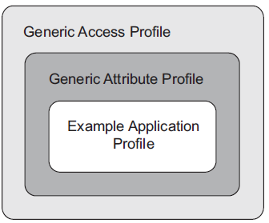

The protocols that are depended to GATT is::
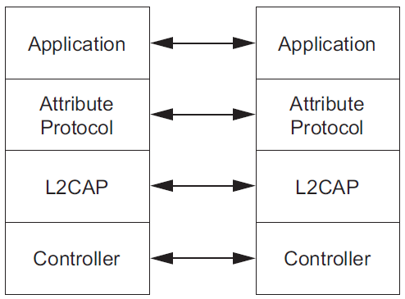

Profile fundamentals::
- This profile can be used over any physical link, using the Attribute Protocol L2CAP channel, known as the ATT Bearer.
- The profile roles are not tied to the Controller roles

ATT Bearer ::
An ATT bearer is a channel used to send Attribute Protocol PDUs. Each ATT bearer uses an L2CAP channel which shall be either a dynamically allocated channel or the LE Attribute Protocol fixed channel
A device may have any number of dynamically allocated channels and at most one fixed channel as ATT bearers to a peer device.
The att bearer is of 2 types
1 - Unenhanced ATT bearer
2 - Enhanced ATT bearer
The L2CAP channel mode determines the behavior of Attribute Protocol on that ATT bearer. If the L2CAP channel mode is using Enhanced Credit Based Flow Control Mode, the ATT bearer is known as an Enhanced ATT bearer. Any ATT bearer that is not an Enhanced ATT bearer, using any other L2CAP channel mode, is known as an Unenhanced ATT bearer
Both are used for connection establishment. Either device may terminate an ATT bearer at any time.

When using an Enhanced ATT bearer over LE, L2CAP connection-oriented channels in Enhanced Credit Based Flow Control Mode are used to transmit Attribute Protocol PDUs. Such channels are established using L2CAP_CREDIT_BASED_CONNECTION_REQ packets.
In both cases, the EATT fixed PSM [1] is used and the ATT bearer is the established L2CAP connection-oriented channel. Multiple L2CAP channels can be established between a client and a server.

When using an Unenhanced ATT bearer, the channel used to carry Attribute Protocol PDUs over LE is the Attribute L2CAP fixed channel. To terminate the ATT bearer, the physical channel has to be disconnected.

NOTE : UNENHANCED ATT BEARER - MTU_SIZE - 23 Octets
ENHANCED ATT BEARER - MTU_SIZE - 64 Octets

ATTRIBUTE PROTOCOL :
- The GATT profile requires the implementation of the Attribute Protocol.
- The GATT Profile uses the Attribute Protocol to transport data in the form of commands, requests, responses, indications, notifications and confirmations between devices.
- The data that is to be transmitted will be present in attribute protocol pdu.
  - 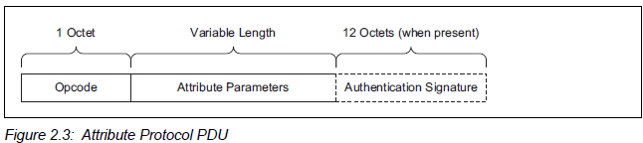
- The Opcode contains the specific command, request, response, indication,notification or confirmation opcode and a flag for authentication. The Attribute Parameters contain data for the specific command or request or the data returned in a response, indication, or notification. The Authentication Signature is optional.

- Attribute Protocol commands and requests act on values stored in Attributes on the server device.
- An Attribute is composed of four parts:
->Attribute Type
->Attribute handle
->Attribute value
->Attribute Permissions

- 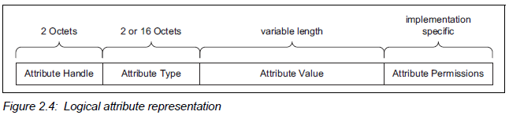
1 - Attribute handle ::

An attribute handle is a 16-bit value that is assigned by each server to its own attributes to allow a client to reference those attributes. An attribute handle shall not be reused while an ATT bearer exists between a client and its server.
Attribute handles on any given server shall have unique, non-zero values. Attributes are ordered by attribute handle.
An attribute handle of value 0x0000 is reserved for future use. An attribute handle of value 0xFFFF is known as the maximum attribute handle.

2 - Attribute Type ::
A universally unique identifier (UUID) is used to identify every attribute type. A UUID is considered unique over all space and time.
The Attribute Protocol allows devices to identify attribute types using UUIDs regardless of the local handle used to identify them in a read or write request.
All 32-bit Attribute UUIDs shall be converted to 128-bit UUIDs when the Attribute UUID is contained in an ATT PDU.

3 -Attribute value ::
An attribute value is an octet array that may be either fixed or variable length.
For example, it can be a one octet value, or a four octet integer, or a variable length string. An attribute may contain a value that is too large to transmit in a single PDU and can be sent using multiple PDUs. The values that are transmitted are opaque to the Attribute Protocol.
The encoding of these octet arrays is defined by the attribute type.
When transmitting attribute values in a request, a response, a notification or an indication, the attribute value length is not sent in any field of the majority of PDUs.
-> only one attribute value can be placed in a single request, response, notification or indication unless the attribute values have lengths known by both the server and client, as defined by the attribute type
There are some PDUs where the length of attribute values is included as a field within the PDU and therefore the above implications do not apply to these PDUs.

4 - Attribute permissions
An attribute has a set of permission values associated with it. The permissions associated with an attribute specifies that it may be read and/or written. The permissions associated with the attribute specifies the security level required for read and/or write access, as well as notification and/or indication. The permissions of a given attribute are defined by a higher layer specification, and are not discoverable using the Attribute Protocol.

Attribute permissions are a combination of access permissions, encryption permissions, authentication permissions and authorization permissions.
The following access permissions are possible:
• Readable
• Writeable
• Readable and writable
The following encryption permissions are possible:
• Encryption required
• No encryption required
The following authentication permissions are possible:
• Authentication Required
• No Authentication Required
The following authorization permissions are possible:
• Authorization Required
• No Authorization Required

Attribute grouping :
The Generic Attribute Profile defines the grouping of attributes for three attribute types
1 - Primary
2 - Secondary
3 - Characteristics.

The primary and secondary service grouping may use ATT_READ_BY_GROUP_TYPE_REQ PDU , but for characteristics grouping we may not use ATT_READ_BY_GROUP_TYPE_REQ PDU.

UUID :
All 16-bit UUIDs shall be contained in exactly 2 octets. All 128-bit UUIDs shall be contained in exactly 16 octets.
All 32-bit UUIDs shall be converted to 128-bit UUIDs when the UUID is contained in an ATT PDU.

GATT PROFILE HIERARCHY :

The GATT Profile specifies the structure in which profile data is exchanged. This structure defines basic elements such as services and characteristics, used in a profile. All of the elements are contained by Attributes. Attributes used in the Attribute Protocol are containers that carry this profile data.

SERVICE DEFINITION ::
A service declaration is an Attribute with the Attribute Type set to the UUID for «Primary Service» or «Secondary Service». The Attribute Value shall be the 16-bit Bluetooth UUID or 128-bit UUID for the service, known as the service UUID. A client shall support the use of both 16-bit and 128-bit UUIDs. A client may ignore any service definition with an unknown service UUID. An unknown service UUID is a UUID for an unsupported service. The Attribute Permissions shall be read-only and shall not require authentication or authorization.
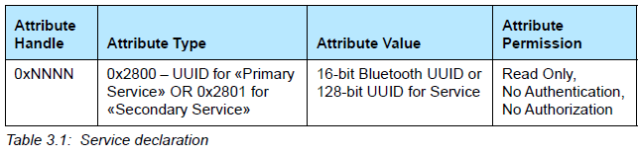

INCLUDE DEFINITION ::
The include declaration is an Attribute with the Attribute Type set to the UUID for «Include». The Attribute Value shall be set to the included service Attribute Handle, the End Group Handle, and the service UUID. The Service UUID shall only be present when the UUID is a 16-bit Bluetooth UUID.The Attribute Permissions shall be read only and not require authentication or authorization.
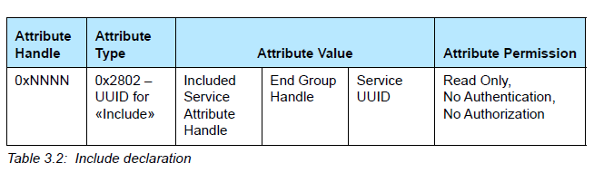

CHARACTERISTIC DEFINITION ::
A characteristic definition shall contain a characteristic declaration, a Characteristic Value declaration and may contain characteristic descriptor declarations. A characteristic definition ends at the start of the next characteristic declaration or service declaration or after the maximum Attribute Handle. Characteristic definitions appear on the server within a service definition in an order based on Attribute Handle.

Characteristic declaration:
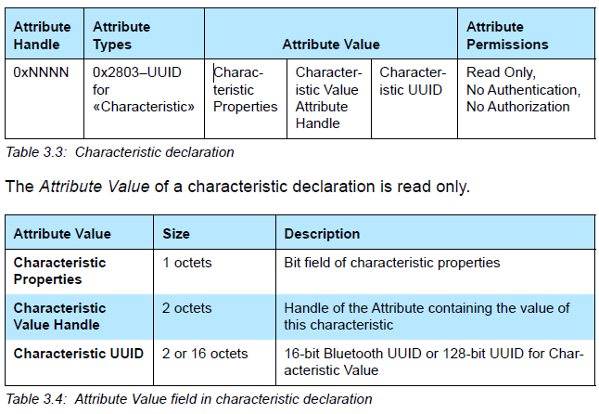

Characteristic Value declaration:
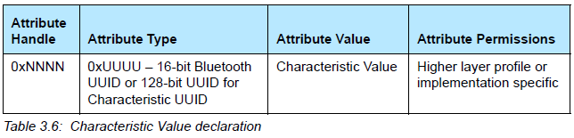

Client Characteristic Configuration
The Client Characteristic Configuration declaration is an optional characteristic descriptor that defines how the characteristic may be configured by a specific client. The Client Characteristic Configuration descriptor value shall be persistent across connections for bonded devices. The Client Characteristic Configuration descriptor value shall be set to the default value at each connection with non-bonded devices.The characteristic descriptor value is a bit field. When a bit is set, that action shall be enabled, otherwise it will not be used. The Client Characteristic Configuration descriptor may occur in any position within the characteristic definition after the Characteristic Value. Only one Client Characteristic Configuration declaration shall exist in a characteristic definition.
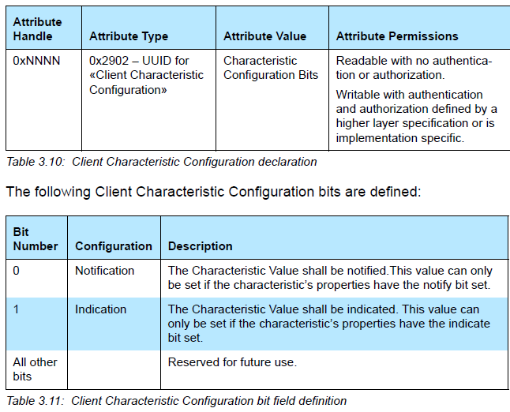
ATTRIBUTES IN GATT
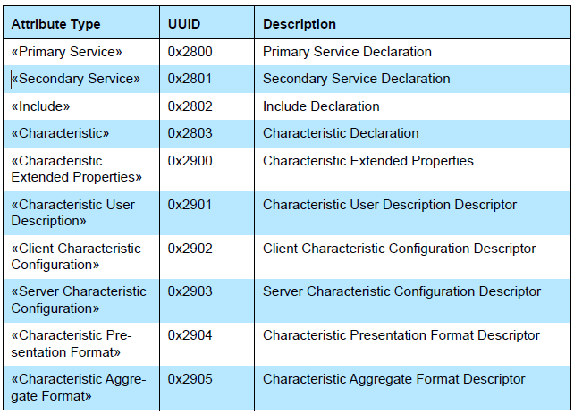

SERVER CONFIGURATION:
This procedure is used by the client to configure the Attribute Protocol. This procedure has only one sub-procedure used to set the MTU sizes.
Exchange MTU:
The ATT_EXCHANGE_MTU_REQ PDU is used by this sub-procedure. The Client Rx MTU parameter shall be set to the maximum MTU that this client can receive.
Two possible responses can be sent from the server for the
ATT_EXCHANGE_MTU_REQ PDU:
ATT_EXCHANGE_MTU_RSP and ATT_ERROR_RSP PDUs.

PRIMARY SERVICE DISCOVERY:

There are two sub-procedures that can be used for primary service discovery:
->Discover All Primary Services
->Discover Primary Services by Service UUID.

Discover All Primary Services
The ATT_READ_BY_GROUP_TYPE_REQ PDU shall be used with the Attribute Type parameter set to the UUID for «Primary Service». The Starting Handle shall be set to 0x0001 and the Ending Handle shall be set to 0xFFFF.
Discover Primary Service by Service UUID
This sub-procedure is used by a client to discover a specific primary service on a server when only the Service UUID is known. The specific primary service
may exist multiple times on a server. The primary service being discovered is identified by the service UUID.
The ATT_FIND_BY_TYPE_VALUE_REQ PDU shall be used with the Attribute Type parameter set to the UUID for «Primary Service» and the Attribute Value
set to the 16-bit Bluetooth UUID or 128-bit UUID for the specific primary service. The Starting Handle shall be set to 0x0001 and the Ending Handle shall be set to 0xFFFF.

RELATIONSHIP DISCOVERY:
This procedure is used by a client to discover service relationships to otherservices.
There is one sub-procedure that can be used for relationship discovery: Find Included Services.
Find Included Services:
The ATT_READ_BY_TYPE_REQ PDU shall be used with the Attribute Type parameter set to the UUID for «Include» The Starting Handle shall be set to the starting handle of the specified service and the Ending Handle shall be set to the ending handle of the specified service.
The sub-procedure may end early if a desired included service is found prior to discovering all the included services of the specified service supported on the server.

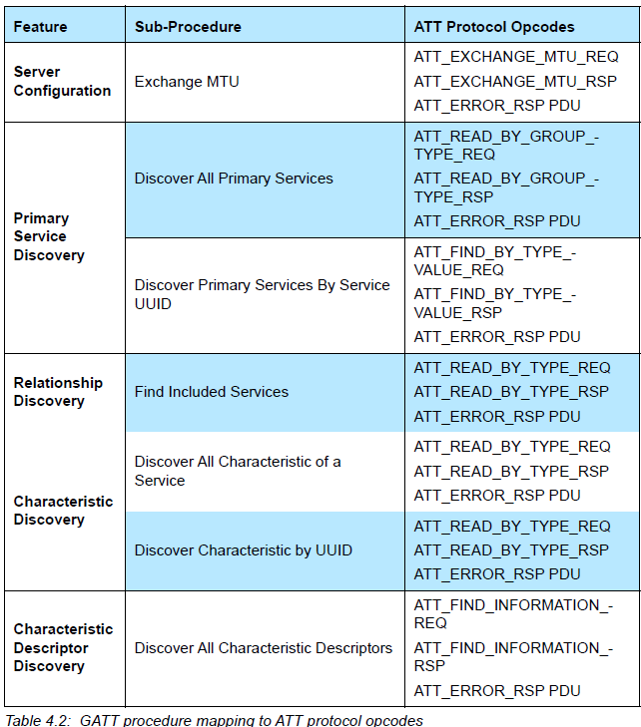

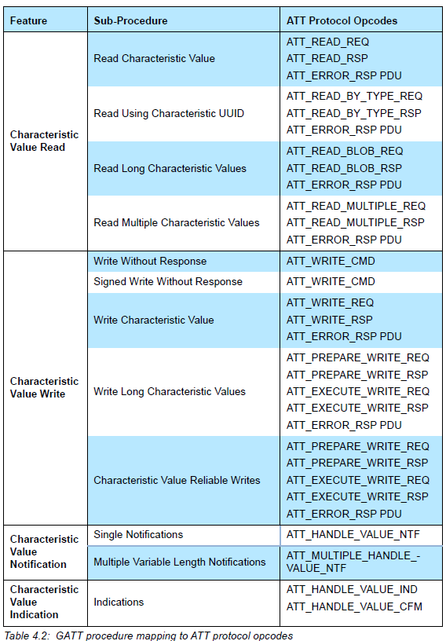

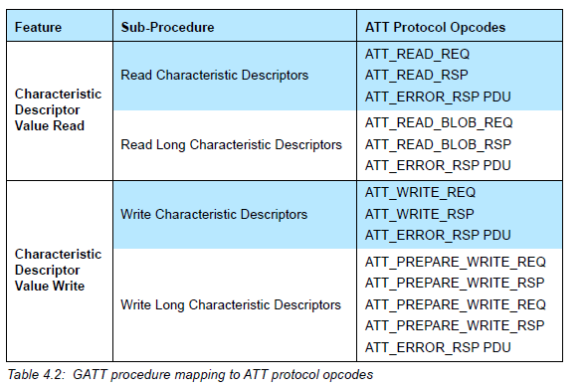

ATT
Tuesday, October 15, 2024
6:38 PM

ATT: - >Attribute protocol
The Attribute Protocol allows a device referred to as the server to expose a set of attributes and their associated values to a peer device referred to as the client. These attributes exposed by the server can be discovered, read, and written by a client, and can be indicated and notified by the server.

Attribute protocol defines 2 roles
1 - server
2 - client
. It allows a server to expose a set of attributes to a client that are accessible using the Attribute Protocol.

An attribute is a discrete value that has the following properties .
->Attribute Type
->attribute handle
->a set of permissions that are defined by each higher layer specification that utilizes the attribute; these permissions cannot be accessed using the Attribute Protocol

->Attribute Type
The attribute type specifies what the attribute represents.

->Attribute handle
The attribute handle uniquely identifies an attribute on a server, allowing a client to reference the attribute in read or write requests.
It allows a client to uniquely identify the attribute being notified or indicated.
Clients are able to discover the handles of the server’s attributes.
Permissions may be applied to an attribute to prevent applications from obtaining or altering an attribute’s value. An attribute may be defined by a higher layer specification to be readable or writable or both, and may have additional security requirements.

All Attribute Protocol requests are sent over an ATT bearer. There can be multiple ATT bearers established between two devices. Each ATT bearer uses a separate L2CAP channel and can have a different configuration.

1 - Attribute Type ::
A universally unique identifier (UUID) is used to identify every attribute type. A UUID is considered unique over all space and time.
The Attribute Protocol allows devices to identify attribute types using UUIDs regardless of the local handle used to identify them in a read or write request

All 32-bit Attribute UUIDs shall be converted to 128-bit UUIDs when the Attribute UUID is contained in an ATT PDU

2 - Attribute handle ::

An attribute handle is a 16-bit value that is assigned by each server to its own attributes to allow a client to reference those attributes. An attribute handle shall not be reused while an ATT bearer exists between a client and its server.
Attribute handles on any given server shall have unique, non-zero values. Attributes are ordered by attribute handle.
An attribute handle of value 0x0000 is reserved for future use. An attribute handle of value 0xFFFF is known as the maximum attribute handle.

3 - Attribute handle grouping
Grouping is defined by a specific attribute placed at the beginning of a range of other attributes that are grouped with that attribute, as defined by a higher layer specification. Clients can request the first and last handles associated with a group of attributes.

4 -Attribute value ::

An attribute value is an octet array that may be either fixed or variable length.
For example, it can be a one octet value, or a four octet integer, or a variable length string. An attribute may contain a value that is too large to transmit in a single PDU and can be sent using multiple PDUs. The values that are transmitted are opaque to the Attribute Protocol.

The encoding of these octet arrays is defined by the attribute type.
When transmitting attribute values in a request, a response, a notification or an indication, the attribute value length is not sent in any field of the majority of PDUs.

-> only one attribute value can be placed in a single request, response, notification or indication unless the attribute values have lengths known by both the server and client, as defined by the attribute type.

There are some PDUs where the length of attribute values is included as a field within the PDU and therefore the above implications do not apply to these PDUs.

5 - Attribute permissions
An attribute has a set of permission values associated with it. The permissions associated with an attribute specifies that it may be read and/or written. The permissions associated with the attribute specifies the security level required for read and/or write access, as well as notification and/or indication. The permissions of a given attribute are defined by a higher layer specification, and are not discoverable using the Attribute Protocol.

Attribute permissions are a combination of access permissions, encryption permissions, authentication permissions and authorization permissions.
The following access permissions are possible:
• Readable
• Writeable
• Readable and writable
The following encryption permissions are possible:
• Encryption required
• No encryption required
The following authentication permissions are possible:
• Authentication Required
• No Authentication Required
The following authorization permissions are possible:
• Authorization Required
• No Authorization Required

6 - Control-point attributes
Attributes that cannot be read, but can only be written, notified or indicated are called control-point attributes. These control-point attributes can be used by higher layers to enable device specific procedures.

7 - Exchanging MTU size
ATT_MTU is defined as the maximum size of any packet sent between a client and a server.
When using an L2CAP channel with a fixed CID, the client and server may optionally exchange the maximum size of a packet that can be received using the ATT_EXCHANGE_MTU_REQ and ATT_EXCHANGE_MTU_RSP PDUs.
A device that is acting as a server and client at the same time shall use the same value for Client Rx MTU and Server Rx MTU. When using an L2CAP channel with a dynamically allocated CID, the ATT_MTU shall be set to the L2CAP MTU size. The ATT_MTU value is a per ATT bearer value. A device with multiple ATT bearers may have a different ATT_MTU value for each ATT bearer.

8 - ATT bearers
An ATT bearer is a channel used to send Attribute Protocol PDUs. Each ATT bearer uses an L2CAP channel which shall be either a dynamically allocated channel or the LE Attribute Protocol fixed channel

A device may have any number of dynamically allocated channels and at most one fixed channel as ATT bearers to a peer device.

The L2CAP channel mode determines the behavior of Attribute Protocol on that ATT bearer. If the L2CAP channel mode is using Enhanced Credit Based Flow Control Mode, the ATT bearer is known as an Enhanced ATT bearer. Any ATT bearer that is not an Enhanced ATT bearer, using any other L2CAP channel mode, is known as an Unenhanced ATT bearer

ISOAL
Tuesday, October 15, 2024
10:34 AM

Isoal layer provides segmentation fragmentation , reassembly and recombination services.
It also coverts the SDU's from upper layer to lower layer as PDU's and viceversaa !!

ISOAL FEATURES :
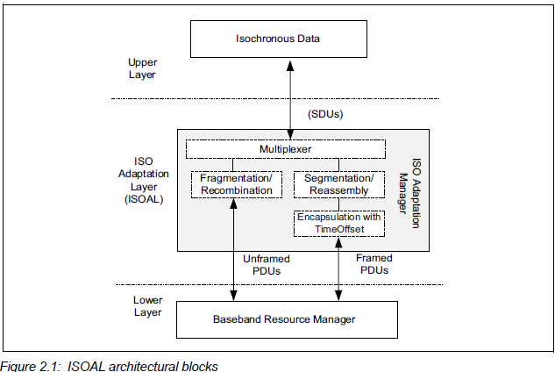

- Fragmentation and recombination.
- Segmentation / reassembly .
- Encapsulation with time Offset.

- Fragmentation and recombination:
The fragmentation process splits an SDU into one or more fragments which are carried by one or more unframed PDUs (see Section 4) in a Connected or Broadcast Isochronous Stream. A fragment shall contain only isochronous data. An SDU with a length less than or equal to the Max_PDU shall be sent in a single unframed PDU. An SDU with a length greater than the Max_PDU shall be sent in multiple fragments in multiple unframed PDUs. The fragmentation process shall use the minimum number of unframed PDUs to transmit the SDU. The recombination process generates an SDU from one or more fragments received in unframed PDUs.

- Segmentation / reassembly
The segmentation process splits an SDU into one or more segments which are carried by one or more framed PDUs (see Figure 2.1) in a Connected or Broadcast Isochronous Stream. A segment shall contain a Segmentation Header (see Section 3) and may contain Time_Offset and isochronous data. The reassembly process combines data from one or more segments received in framed PDUs and generates one or more SDUs.

- Encapsulation and Time Offset
In the encapsulation process Segmentation Headers and a Time_Offset parameter are added before the first segment of each new SDU allowing timing reconstruction at the peer device.

When the Host requests the use of framed PDUs, the Controller shall use framed PDUs.
Unframed PDUs shall only be used when the ISO_Interval is equal to or an integer multiple of the SDU_Interval and a constant time offset alignment is
maintained between the SDU generation and the timing in the isochronous transport.
Framed PDUs are not restricted by the limitations of unframed PDUs and can support any valid combinations of SDU_Interval and ISO_Interval.

UNFRAMED PDU
- The unframed pdu contains the iso data pdu , it has the payload without the header or anything !! It contains the data from a single sdu.
- There are two types of unframed pdus
  - An unframed PDU containing an end fragment or a complete SDU.
  - An unframed PDU containing a start or a continuation fragment.
- The unframed pdu are identified by LLID
  - If LLID = 0b00
->When the payload of the ISO Data PDU contains the end fragment of an SDU.
->When the payload of the ISO Data PDU contains a complete SDU.
- If LLID = 0b01
->When the payload of the ISO Data PDU contains a start or a continuation fragment of an SDU.
->When the ISO Data PDU is used as padding. This is required when the fragments do not add up to the configured number of PDUs specified by the BN parameter per BIS or CIS event.
- Each SDU shall generate BN ÷ (ISO_Interval ÷ SDU_Interval) fragments. All these fragments shall be sent to the Link Layer before any fragments of the
next SDU. If an SDU generates less than this number of fragments, empty payloads shall be used to make up the number. Empty payloads shall be PDUs with LLID 0b01 with zero length payload, e.g., when BN=4 and only 3 PDUs are generated from the SDU, an additional padding PDU needs to be added. When an SDU contains zero length data, the corresponding PDU shall be of zero length and the LLID field shall be set to 0b00.

FRAMED PDU
- A framed PDU is an ISO Data PDU where the payload field is made up of segments or is empty. Each segment is encapsulated by a Segmentation
Header and, for each first segment of a new SDU, a Time_Offset field is included to allow for reconstruction of the original SDU timing.
Each framed PDU starts with a Segmentation Header that contains a SC,
Depending on the SC field, an additional Time_Offset parameter is included between the Segmentation Header and the start of SDU data to indicate the relative timing difference between the SDU and CIG reference point or BIG anchor point timing. CMPLT and a Length field.

The Segmentation Header includes the SC and the CMPLT fields with the following requirements:
• When SC is set to 0, it indicates the start of a new SDU and that the data that follows the header is part of a new SDU. If SC is set to 1, it indicates a continuation of an SDU that was partially transmitted in a previous isochronous PDU.
• When SC is set to 0, the Segmentation Header shall be followed by a Time_Offset field, otherwise the Time_Offset is omitted and the header is directly followed by a segment of an SDU.
• When CMPLT is set to 0, not all data of the SDU has been included in the current PDU. One or more additional framed PDUs are required to complete the SDU transfer. When CMPLT is set to 1, all remaining data of the SDU is included in the segment and the SDU may be transferred to the higher layer.
• CMPLT is independent of the value of SC.

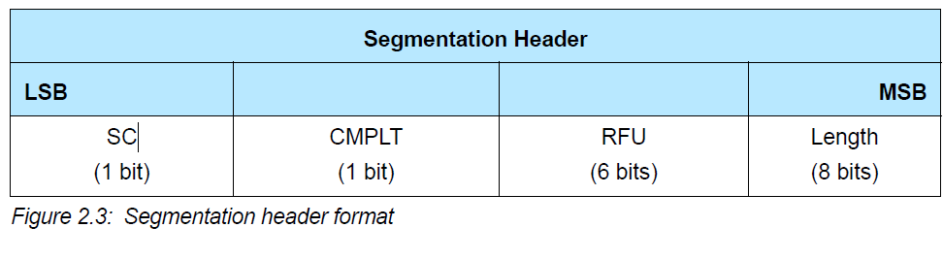

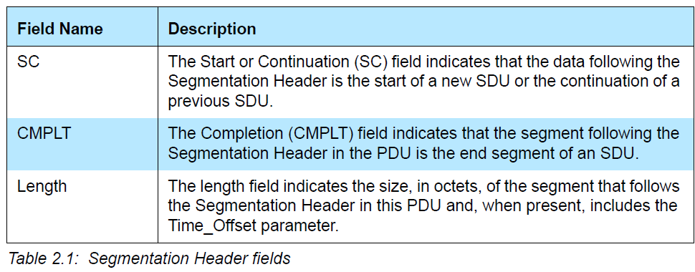

- TIME_STAMP AND TIME_OFFSET
  - Framed PDUs include a Time_Offset field to allow the reconstruction of the original SDU timing. When using HCI ISO Data packets, a Time_Stamp field may be included. This section defines the usage of these parameters. Every Time_Stamp and Time_Offset shall be derived from a free running reference clock that is not affected by adjustments to synchronize with other devices.
  - TIME_OFFSET IN FRAMED PDUS
  - TIME STAMP FOR SDU

Wednesday, December 4, 2024
12:11 PM

PACS
Publishes audio capabilities service :
Which define the total capabilities of an Acceptor. I has both sink and source role. It also contain pac records which include the information regarding codec and configuration which it suports also with optional features.
PACS specifies information which an Initiator obtains when it starts the process of configuring and establishing an audio stream.
An important concept about the information specified by PACS is that it is a statement of fact about the total capabilities of an Acceptor. The intent is that this should result in an efficient configuration process, especially when multiple Acceptors are involved, particularly if they come from different manufacturers and have differing capabilities.
Aim of pacs is to avoid the dead lock and other issues..

How a pac record will be for source and sink
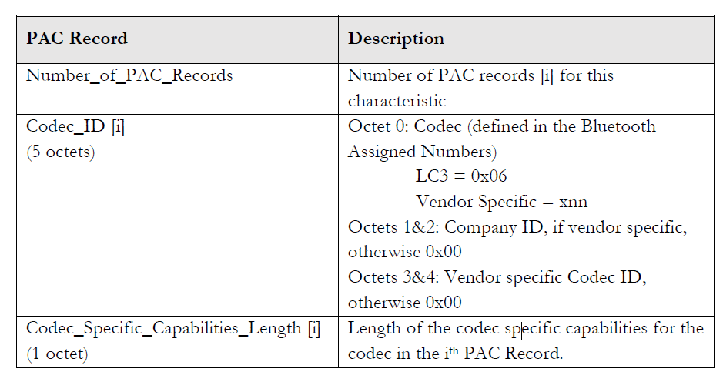

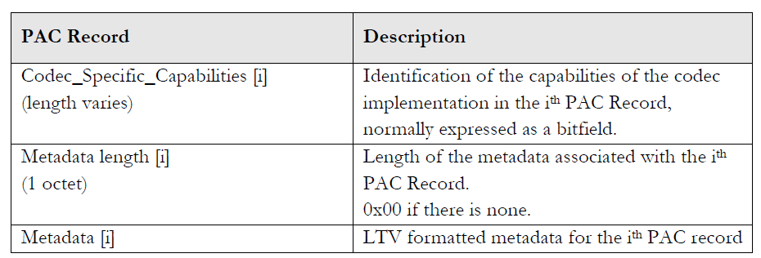

ASCS :
Audio stream control service :

That range needs to be narrowed down to individual sets of parameters to establish Audio Streams, typically because of current resource constraints, such as when an Acceptor is supporting multiple Audio Streams, which may need different parameters. This is where the Audio Stream Control Service comes into play, by defining Endpoints for each Audio Stream.
The Audio Stream Control Service is implemented on an Acceptor and defines how an Initiator can configure and establish an Audio Stream between the two of them, using the procedures defined in BAP.

Audio Stream Endpoints
At the heart of the Audio Stream Control Service is the concept of Audio Stream Endpoints. An Audio Stream Endpoint or ASE is defined as the origin or destination of a unicast Audio Stream in an Acceptor.

ADV & CONN(unicast)(earbuds)
Wednesday, October 16, 2024
5:27 PM

Advertising :
Advertising is the process by which a BLE device (such as a smartphone, sensor, or smartwatch) sends out packets of data over the air to announce its presence and capabilities to other nearby BLE devices. Advertising allows BLE devices to make themselves discoverable and to initiate connections or other types of communication.

There are different types of advertising in BLE:
- Active Advertising: The device transmits advertising packets and may expect responses - (such as a connection request).
- Passive Scanning: Devices that listen for advertising packets but don't respond (typically used to discover other devices).

Two types of advertising:
1 - Legacy advertising : It is the basic advertising method where devices broadcast their presence and some additional data to make themselves discoverable by other devices. In legacy advertising, a Bluetooth LE device (such as a smartphone, wearable, or IoT device) sends out advertising packets that allow nearby devices to detect it and establish a connection.
2 - Extended advertising : Extended advertising supports a much larger advertising packet size and additional functionalities that improve performance, scalability, and efficiency in Bluetooth LE networks.

Advertising PDU
Legacy advertising Pdu
1 - ADV_IND
2 - ADV_DIRECT_IND
3 - ADV_NONCONN_IND
Extended advertising Pdu
4 - ADV_EXT_IND
5 - AUX_ADV_IND
6 - AUX_SYNC_IND
7 - AUX_CHAIN_IND
8 - AUX_SYNC_SUBEVENT_IND
9 - AUX_SYNC_SUBEVENT_RSP

Common Extended Advertising Payload Format
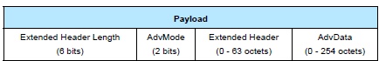

-> The Extended Header Length is a value between 0 and 63 and indicates the size of the variable length Extended Header field.
-> The AdvMode field indicates the mode of the advertisement.
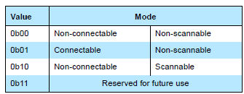
->The AdvData field shall contain advertising data from the advertiser’s Host. The maximum size of AdvData depends on the size of the Extended Header.
If u want to know the advertising data length then you need to subtract extended header + one octet then u get the exact length of advertising data.

-> Next is extended Header which has different fields based on the adv Mode the bits will be enabled and
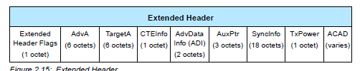

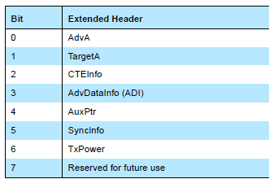

Legacy advertising is not mainly used in LE audio , extended advertising pdu are only used.
1 - ADV_EXT_IND
It has the extended advertising payload ,
An advertising event using an ADV_EXT_IND PDU is directed if, and only if, either the TargetA field is present or the AuxPtr field is present and points to a PDU where the TargetA field is present.
In this we got the information that which are mandatory fields for different event types & if you are using any aux packet then it is aux_adv_ind.
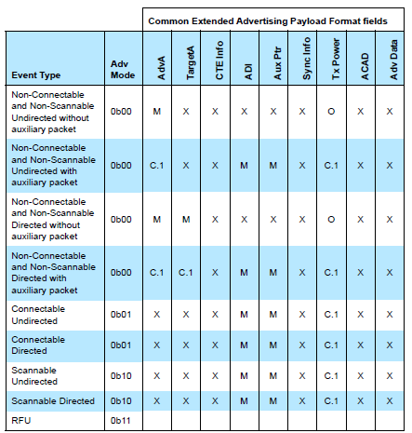
For ADV_EXT_IND --- ADI & AUX_PTR are mandatory for Connectable undirected

2 - AUX_ADV_IND
It also uses the same headerformatt which the ADV_EXT_IND is using i.e common extended advertising payload format
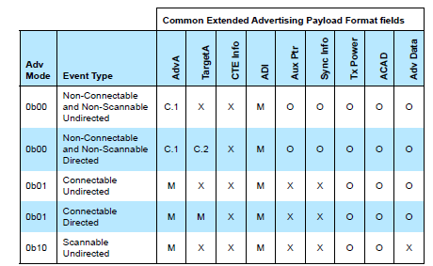
For AUX_ADV_IND --- ADVA & ADI are manditory for Connectable undirected

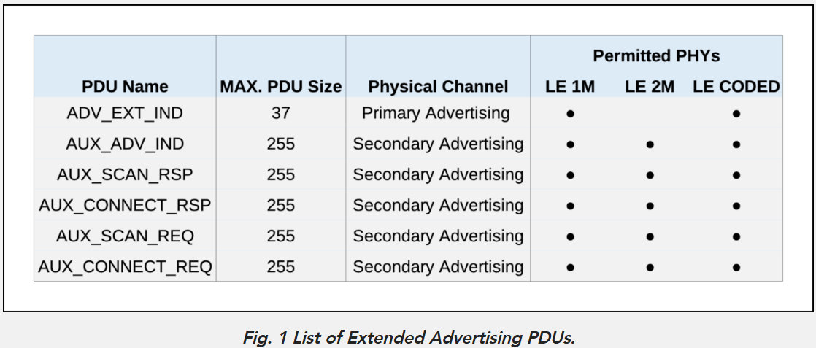

----------------------------------------------info from ota logs ---------------------------------------------------------------------------------------
Mainly above two modes are used in unicast earbud advertising , to know it we go deep into it ..

In the advertising there are 2 packets used mainly
Common extended advertising header -- through this header only we see all the data is included..

In that adv_ext_ind is used which contain ADI & Aux_packet_ptr
Another one is aux_adv_ptr its has two fields enabled ADI , adv data & Adv address.
There are the maditory fields that are used in this adv packets

The information in Adv_ext_ind packet from linklayer

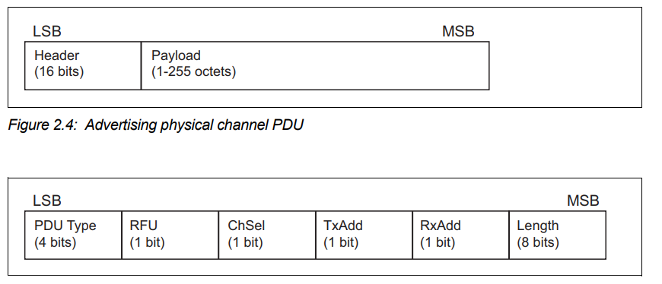
In the linklayer info the advertising physical channel pdu is used in that mainly pdu type is mentioned and length the payload , and in payload Common extended advertising header is used with its details
The payload below

The extended header length is given in bits and selected the adv mode 'then extended header in that we have one octet that is reserved to select the fields that need to be included in the header based on pdu type.
Now for adv_ext_ind 2 flags are enabled ADI & aux_packet_pointer
Coming to ADI -- advertising data info
It has 2 fields of 2 octets
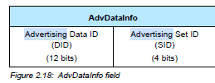
1. Advertising Set ID (SID)
The Advertising Set ID (SID) is an identifier used to differentiate between multiple advertising sets being transmitted by a single device.
- What is an Advertising Set?
  - An advertising set is a group of advertising data packets that are sent together as part of a single advertising sequence. For instance, a device might be broadcasting multiple types of information in different advertising packets. Each type of data (e.g., device name, available services, audio streaming capabilities) can be grouped in separate sets. The SID tells the receiving device which set each packet belongs to.
- Why is it Important?
  - When a Bluetooth LE device transmits multiple sets of advertising data, the SID helps to distinguish which set the current advertising data belongs to. This is useful for handling multiple types of advertisements at once (such as advertising different services, profiles, or audio streams).
- Example: If you have a Bluetooth LE device transmitting two types of advertising data sets—one for a heart rate monitor service and another for a Bluetooth LE audio streaming service—each of these sets would have a unique Advertising Set ID (SID), so devices receiving the data know which set of information they are receiving.

2. Advertising Data ID (DID)
The Advertising Data ID (DID) helps the scanning device (the one receiving the advertising data) determine whether the advertising data in the current packet is a duplicate of the previous packet or new data.
- What Does This Mean?
  - Advertising in Bluetooth LE can happen in multiple packets or frames, especially when the data is large or needs to be sent at regular intervals. To avoid redundant processing and save power, the DID is used to indicate to the scanning device whether the contents of the current advertisement are the same as the data from a previous advertisement packet.
- Why is it Important?
  - If the DID indicates that the advertising data is the same as a previous packet (i.e., a "duplicate"), the scanning device can ignore the current packet and not re-process the same data. This is useful for devices that are scanning over a longer period and helps to reduce unnecessary work and energy consumption, especially when the same advertisement is repeated in multiple packets.
  - If the DID indicates that the packet contains new data (i.e., it’s different from previous advertisements), the scanner will process the new data and act on it (e.g., connect to the device or display information to the user).
- Example:
  - A Bluetooth LE audio device might be advertising continuously, sending the same data about its audio capabilities in every packet. After receiving the first advertisement packet, a scanning device might receive a second packet. If the DID is the same in both packets, the scanning device knows that the content hasn’t changed, so it can skip processing the second packet. If the DID changes, the scanning device knows that the packet contains new information and processes it accordingly.

2 Aux packet pointer is also maditory in adv_ext_ind.
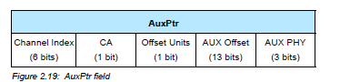

Here we have a channel Index --
The Channel Index field contains the general-purpose channel index , that are used for transmitting aux packets
The channel indexes are 0 - 39 channels are used in advertising as it is extended advertising.

Aux Phy :;
The Aux PHY field indicates the PHY used to transmit the auxiliary packet. The value of the Aux PHY field shall be set as
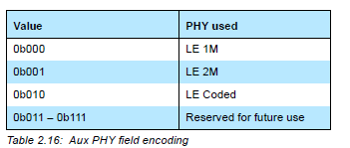

CA -- CLOCK ACURACY
The CA field contains the clock accuracy of the advertiser that will be used between the packet containing this data and the auxiliary packet.
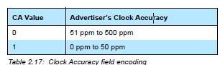

AUX offset
The Aux Offset field defines the time difference between a reference point (typically the start of a packet containing the AuxPtr field) and the start of an auxiliary packet. In other words, the Aux Offset tells you how long after the reference point the auxiliary packet should start. However, Aux Offset is just a raw numeric value, and without the Offset Units, it would be unclear in what time scale or units that value is measured.

Aux units
The Aux Offset also cannot be less than 245,700 μs (about 245.7 ms), and if it is smaller than that, the Offset Units field must be set to 0 (presumably indicating microseconds).
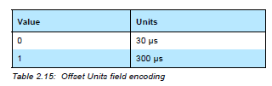
T_MAFS

Now in the same way if we come to Aux_adv_ind
There are 3 flags enabled ADI , AdvA ADVdata
ADI is same as the above mention DID SID
AdvA:
The Advertising Address field contains the advertiser’s device address. If the AdvA field is present, TxAdd in the advertising physical channel PDU header indicates whether this address is public (TxAdd = 0) or random (TxAdd = 1).
According to this the txaddress in adv physical channel pdu indicates the type pubilc or random and in payload header its presents the address..where it is off 6 bytes..
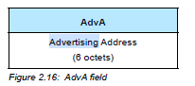

Advertising Data ::
Which contains some raw data and local name of the device and its info
--------------------------------------------------------------------------------------------------------------------------------------------------------------------------------------------------------------
Here above information is about linklayer packet now let see about linklayer information.
Sniffer radio ::
-->RSSI :
In Bluetooth Low Energy (BLE), RSSI stands for Received Signal Strength Indicator, which is a measure of the strength of the radio signal received by a device.
RSSI is typically measured in dBm (decibels milliwatts). The value is always negative because it represents the attenuation of the signal (the more negative the value, the weaker the signal). The RSSI value is usually in the range of -100 dBm (very weak signal) to 0 dBm (very strong signal), with typical values being in the range of -60 dBm to -90 dBm for devices in normal operating conditions.

-->Rx quality:
The quality of signal that is good or average based on the RSSI value
-->Gain --By the above values the gain is nothing but the strength of the signal transmitted or received by anteena

RF Channel:
RF channel frequency
It is the frequency of the particular channel selected
RF channel number
The channel number is of the channel nothing but the sequence number.
RF channel Index
The channel index which selected for transmission
Initial center freq
Its is of 0 the center freq
Link layer info :
Phy
Coding scheme
Accessaddress
Receivers accessaddress
Crc initial seed
Physical channel
Timing Info :
Start time
Duration
Delta from previous
Aux_ptr pointing to packet
Devices::
Transmitter & Receiver

These are the main pdu used in le audio advertising of earbuds ..
-------------------------------------------------------------------------------------------------------------------------------------------------------------------------------------------------------

Connection::
The connection is same as Normal BLE connection but the packets sent for connect request is different.
Here we are Aux_Connect_req & Aux_Connect_Rsp

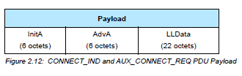

Transmitted address and receiver address type will be represented in the header of advertisement pdu where it may be pubilc or Random.
Then channel selection in that pdu is rfu.

In Payload u see initiator address and advertiser address and linklayer data.
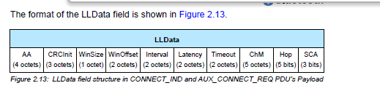
The aux_conn_req has sub fields of 22octects
We will get know one by one..
AA - contains the ACL connection’s Access Address determined by the Link Layer.
The Access Address shall be a 32-bit value. Each time it needs a new Access Address (except for a Broadcast Isochronous Stream (BIS)), the Link Layer shall generate a new random value.
The Link Layer in the Central Role in the Connected State shall generate a new Access Address for each Connected Isochronous Stream (CIS) it creates. The address is sent in the Link Layer Control PDU that is used to create the CIS

CRC Initial seed -
contain the initialization value for the CRC calculation for the ACL connection.
It shall be a random value, generated by the Link Layer. The seed for the random number generator shall be from a physical source of entropy and should have atleast 20 bits of entropy.
In BLE, a 24-bit CRC is used to ensure data integrity for certain types of packets, particularly Data Physical Channel PDUs and Connected Isochronous PDUs.

Window size -
The transmit window is calculated based on the following formula:
- Start of Transmit Window = transmitWindowDelay + transmitWindowOffset
- End of Transmit Window = Start of Transmit Window + transmitWindowSize
- transmitWindowOffset is a multiple of 1.25 ms and is in the range 0 ms to Conn Interval.
  - Conn Interval is the time between two consecutive connection events (defined during the connection setup).
- transmitWindowSize is also a multiple of 1.25 ms and must be between 1.25 ms and the smaller value of:
  - 10 ms, or
  - (Conn Interval - 1.25 ms). This means the window can’t be larger than the available time within a connection event.
The value of transmitWindowDelay (the delay before the transmit window begins) depends on the type of PDU being used:
- For CONNECT_IND PDU: The delay is 1.25 ms .
- For AUX_CONNECT_REQ PDU on LE Uncoded PHY: The delay is 2.5 ms .
- For AUX_CONNECT_REQ PDU on LE Coded PHY: The delay is 3.75 ms.

Channel mapping
The ChM field shall contain the channel map indicating Used and Unuseddata channels. Every channel is represented with a bit positioned as per the data channel index as defined in Section 1.4.1. The LSB represents data channel index 0 and the bit in position 36 represents data channel index 36. A bit value of 0 indicates that the channel is Unused. A bit value of 1 indicates that the channel is Used. The bits in positions 37, 38 and 39 are reserved for future use.

Hop increment :
The Hop field shall be set to indicate the hopIncrement used in the data
It shall have a random value in the range 5 to 16 channel selection.

Supervision timeout
Connection supervision timeout (connSupervisionTimeout) is a parameter that defines the maximum time between two received Data Channel PDUs or Connected Isochronous PDUs before the connection is considered lost. The connSupervisionTimeout shall be a multiple of 10 ms in the range 100 ms to 32.0 s and it shall be larger than (1 + connPeripheralLatency) × connSubrateFactor × connInterval × 2.

AUX_CONNECT_RSP :
The AUX_CONNECT_RSP PDU uses the Common Extended Advertising Payload Format
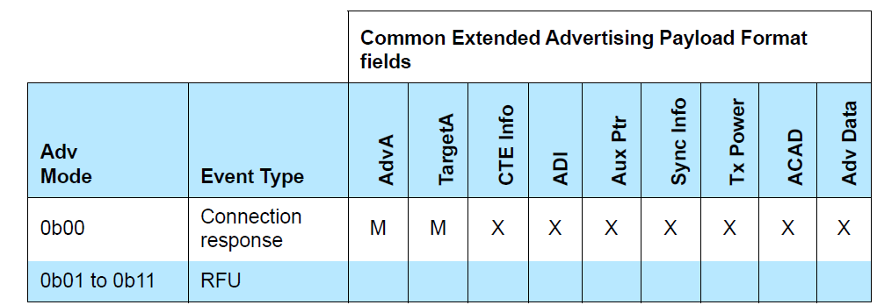

The AdvMode field shall be set to 0b00.
In the aux_connect response we have only 2 fields enabled. i.e AdvA and TargetA
Which is target address and advertise address - both is of 12 bytes 6 bytes each..

----------------------------------------------------------------------------------------------------------------------------------------------------------------------------------------------------------------

Conn procedure - after aux_conn_resp
Monday, November 11, 2024
3:04 PM

Once connect request and response is done there will be link layer commands will be exchanged..

1 - LLCP version exchange
2 - LLCP Feature exchange
3 - LLCP Channel map indication
4 - LLCP Peripheral feature exchange

Here we are using Data physical channel PDU
The Data Physical Channel PDU has a 16 or 24 bit header, a variable size payload, and may include a Message Integrity Check (MIC) field.
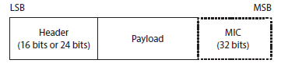
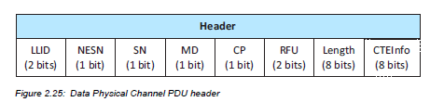
The MIC field shall not be included in an un-encrypted ACL connection, or in an encrypted ACL connection with a Data Channel PDU with a zero length Payload.
The MIC field shall be included in an encrypted ACL connection, with a Data Channel PDU with a non-zero length Payload.2713
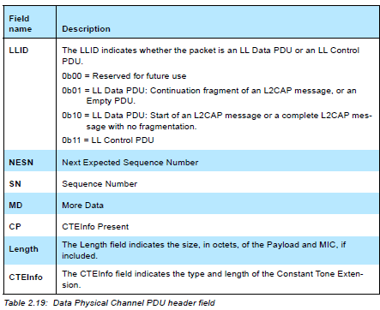

LLID --
The LLID indicates whether the packet is an LL Data PDU or an LL Control
PDU.
0b00 = Reserved for future use
0b01 = LL Data PDU: Continuation fragment of an L2CAP message, or an
Empty PDU.
0b10 = LL Data PDU: Start of an L2CAP message or a complete L2CAP message
with no fragmentation.
0b11 = LL Control PDU

Based on the LLID its is know that which type of packets is sent like data or control packet.

There are different control packets that should be transferred based on the opcode.

Once after the connection conn req and conn resp.
LLCP packets are exchanged in flow
so first comes version exchange
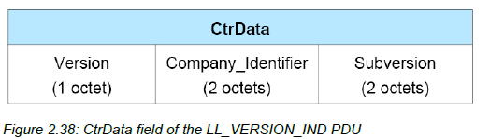
Here It will be using data physical channel pdu
version specifies the core specification using
Version field shall contain the version of the Bluetooth Link Layer specification
supported by the Controller
company identifer show the company name
Company_Identifier field shall contain the company identifier of the manufacturer of the
Bluetooth Controller
subversion
Subversion field shall contain a unique value for each implementation or revision of an
implementation of the Bluetooth Controller

Feature Exchange

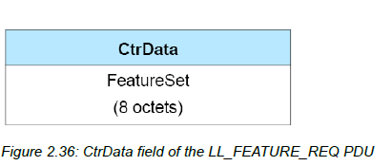
What all the features that is supporting and sent to peer device
Both request and response are send from both central and peripheral.

LLCP channel map indication
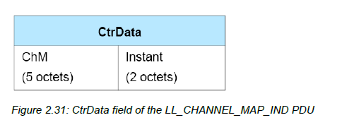
The ChM field shall contain the channel map indicating Used and Unused data channels. Every channel is represented with a bit positioned as per the data channel index

LL_PERIPHERAL_FEATURE_EXCHANGE
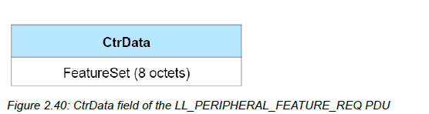

FeatureSet shall contain the set of features supported by the Peripheral’s Link Layer.
both request and response are present

After this pairing will be done i.e secure connection that contains 5 steps.
after authentication will have encryption

LL_ENC_REQ
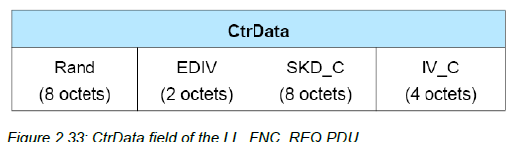

The Rand field shall contain a random number that is provided by the Host and used
with EDIV
The EDIV field shall contain the encrypted diversifier.
The SKD_C field shall contain the Central’s portion of the session key diversifier.
The IV_C field shall contain the Central’s portion of the initialization vector.

LL_ENC_RSP
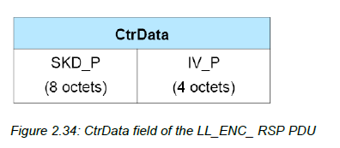
The SKD_P field shall contain the Peripheral’s portion of the session key diversifier.
The IV_P field shall contain the Peripheral’s portion of the initialization vector.

LL_START_ENC_REQ & LL_START_ENC_RSP
This commands does the contain any control data.

LL_CLOCK_ACCURACY_REQ and LL_CLOCK_ACCURACY_RSP
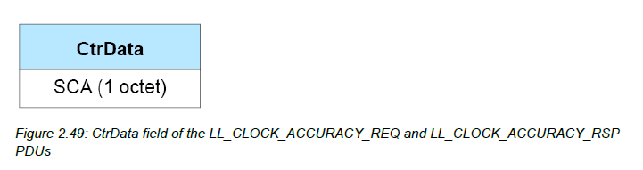
The SCA field shall indicate the current centralSCA (if the PDU is sent by the Central) or peripheralSCA (if the PDU is sent by the Peripheral) used to determine the worst case sleep clock accuracy of the sending device.

LL_LENGTH_REQ and LL_LENGTH_RSP
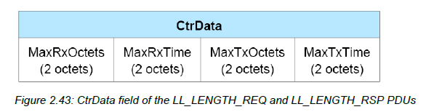
connInitialMaxTxOctets - the value of connMaxTxOctets that the Controller will use
for a new connection.
connInitialMaxTxTime - a value that the Controller will use to determine the value of
connMaxTxTime that it will use for a new connection.
supportedMaxRxOctets - the maximum value of connMaxRxOctets that the Controller
supports.
supportedMaxRxTime - the maximum value of connMaxRxTime that the Controller
supports.

LE AUDIO BASICS
Thursday, October 17, 2024
11:40 AM

Bluetooth LE Audio architecture::
In the Host, there is a new structure called the Generic Audio Framework or GAF. This is an audio middleware, which contains all of the functions which are considered to be generic, i.e., features which are likely to be used by more than one audio application. The Core and the GAF are the heart of Bluetooth LE Audio. They provide great flexibility. Finally, at the top of the stack, we have what are termed “top level” profiles, which add application specific information to the GAF specifications.
Figure
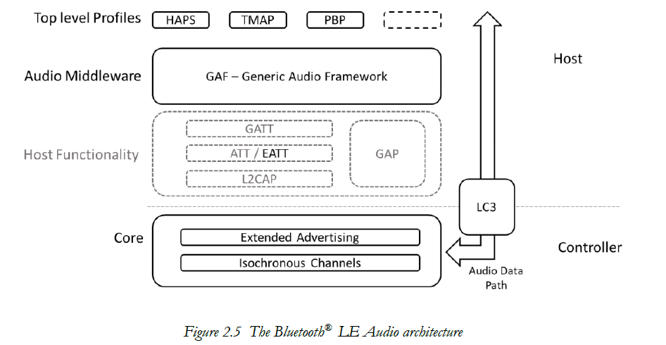

Profiles and Services ::
In Bluetooth LE, Profiles and Services can be considered as Clients and Servers. Service specifications define one or more characteristics which can represent individual features or the states of a state machine. They can also be control points, which cause transitions between the states of a state machine. Profiles act on these characteristics, reading or writing them and being notified whenever the values change. Multiple devices, each acting as Clients, can operate on a Server.

In Bluetooth LE Audio, the many-to-one topology is much more common, particularly in features like volume control and the selection of a Broadcast Source, where a user may have multiple devices implementing the Profile specification and acting as a Client. In most cases, these act on a first come, first served basis.
The number of different control profiles that can be used in Bluetooth LE Audio drove the EATT enhancement to the Core. Profiles and Services communicate using the Attribute Protocol (ATT), but ATT assumes that only one command is occurring at a time. If more than one is happening, the second command can be delayed, because ATT is a blocking protocol. To get around this, the Extended Attribute Protocol (EATT) was added in Core 5.2 release, allowing multiple ATT instances to operate at the same time.
overview of the Bluetooth LE Audio architecture:
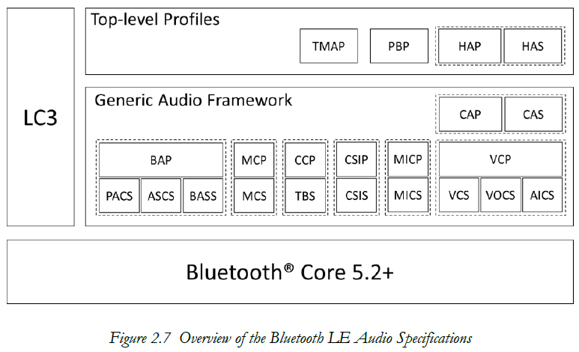

The Generic Audio Framework::
In the generic audio framework has different groups which is used for volume control , stream control , content control , capture control.

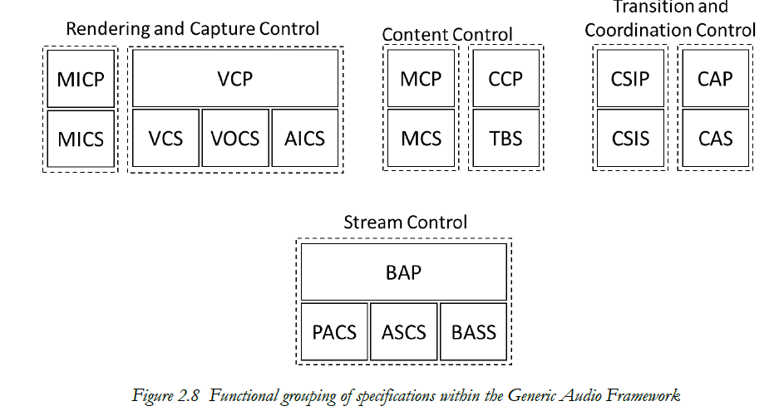

Stream configuration and management
In this Stream configuration and management there is 4 blocks known as the BAPS specifications. These four specifications form the foundation of the Generic Audio Framework. At their core is BAP – the Basic Audio Profile, which is used to set up and manage unicast and broadcast Audio Streams.

Here the profile is BAP and has three services
1 - PACS
2 - ASCS
3 - BASS

BAP – the Basic Audio Profile
PACS - Published Audio Capabilities Service
ASCS - Audio Stream Control Service
BASS - Broadcast Audio Scan Service

BAP is used to setup and manage unicast broadcast audio steam and its needs three services that are PACS , ASCS ,BASS.

PACS which exposes the capabilities of a device.
ASCS which defines the state machine for setting up and maintaining unicast audio streams.
BASS which defines the procedures for discovering and connecting to broadcast audio streams and distributing the broadcast encryption keys.
These services are responsible for the way we set up the underlying Isochronous Channels which carry the audio data.

The states of the audio stream
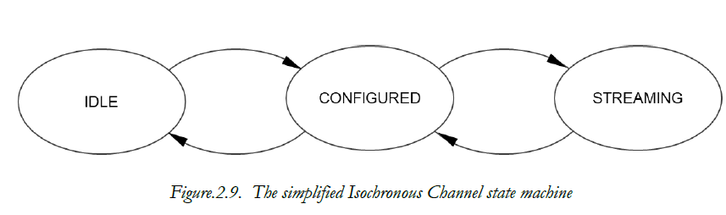
For unicast, the state machine is defined in the ASCS specification. The state resides within individual audio endpoints in the Server, with the Client control defined in BAP.
For broadcast, where there is no connection between the transmitter and receiver, the concept of a Client-Server model becomes a little tenuous.
You can make a Bluetooth LE Audio product with just three of these specifications; BAP, ASCS and PACS for unicast and BAP alone for broadcast

Rendering and capture control:
Having set up a stream, users want to control the volume, both of the audio streams being rendered in their ears and the pick-up of microphones.
Profile - Volume control profile
Here the volume control is very difficult so for this we have different service that helps they are :
1 - Volume control service
2 - Volume offset control service
3 - Audio Input control service

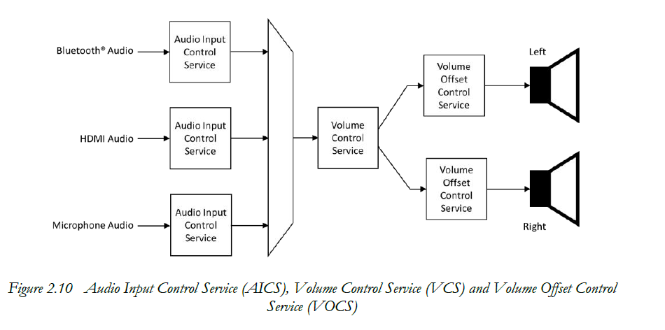

A complementary pair of specifications, MICP and MICS, the Microphone Control Profile and Service, are responsible for controlling the microphones that reside within hearing aids and earbuds.
MICP works in conjunction with AICS and MICS to control the overall gain and muting of multiple microphones. They are normally used for control of the captured audio that is destined for a Bluetooth stream, but can be used more widely.
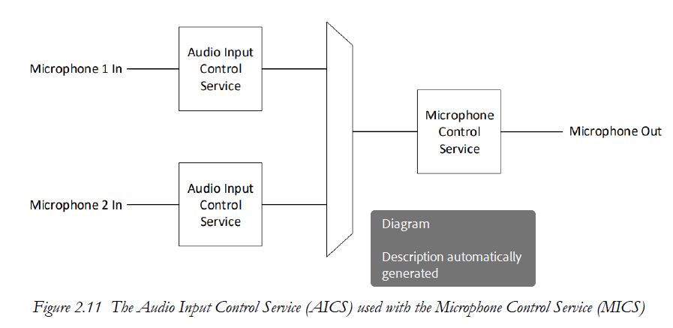

Content control

The content control is used to control the stream.
The Media Control Service (MCS) resides on the source of audio media and reflects the state of the audio stream. The state machine allows a Client using the Media Control Profile (MCP) to transition each media source through Playing, Paused and Seeking states. At its simplest, it allows an earbud to control Play and Stop.
Telephony control is handled in a similar way using the Telephone Bearer Service (TBS), which resides on the device involved in the call (typically the phone, PC or laptop), with the complementary Call Control Profile (CCP) controlling the call by writing to the state machine in the TBS instance.
Both TBS and MCS acknowledge the fact that there may be multiple sources of media and multiple different call applications on the Server devices. To accommodate this, both can be instantiated multiple times – once for each instance of an application. This allows a Client with the complementary profile to control each application separately. Alternatively, a single instance of the service can be used, with the media or call device using its specific implementation to direct the profile commands to the correct application. The single instance variants of TBS and MCS are known as the Generic Telephone Bearer Service (GTBS) and Generic Media Control Service (GMCS).
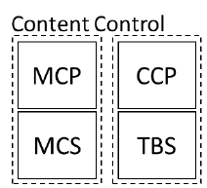

Transition and coordination control::
The Transition and coordination control is mainly used for coordination , synchronization of devices so its supports different profiles and services , they are :
1 - CSIP
2 - CSIS
3 - CAP
4 - CAS
Top level Profiles::
On top of the GAF specifications, we have top level profiles which provide additional requirements for specific audio use cases.
1 - HAPS
2 - TMAP
3 - PBP
Low Complexity Communications Codec
the Bluetooth LE Audio releases include a new, efficient codec called LC3 which is the mandated codec for Bluetooth LE Audio Streams. This provides excellent performance for telehony speech, wideband and super-wideband speech and high-quality audio and is the mandated codec within BAP.

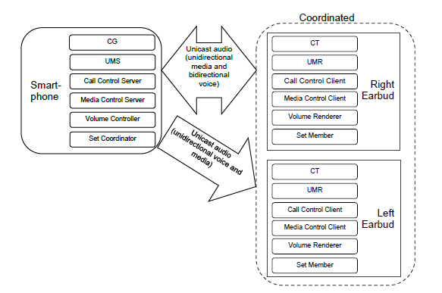

LE_AUDIO_STARTUP
Thursday, October 17, 2024
4:27 PM

The manditory codec for audio we use the LC3 codec , the code has its configuration to play audio in isochronous channels
The main features that are included in LE_Audio
1 - Broadcast source
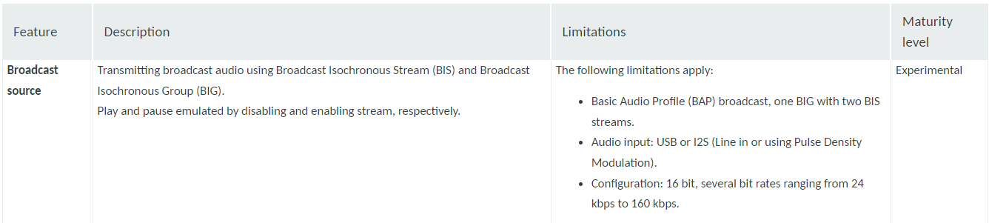

2 - Broadccast sink
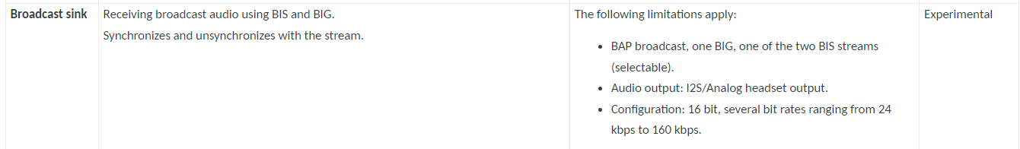

3 - Unicast client
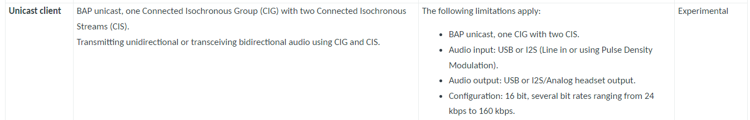

4 - Unicast server
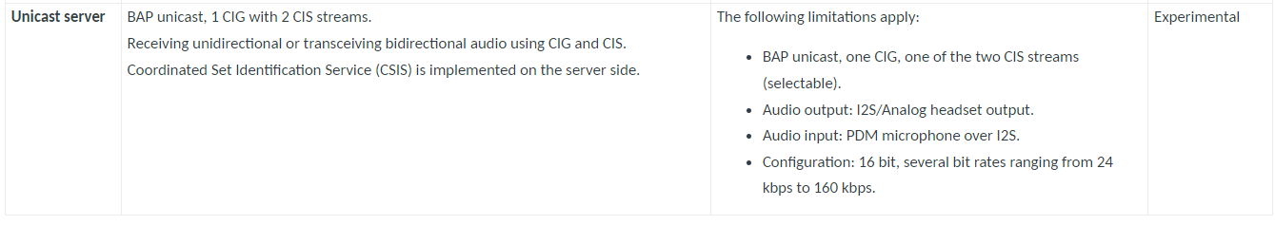
The application can be of 2 Modes
1 - Connected isochronous stream (CIS) mode
2 - Broadcast isochronous stream (BIS) mode
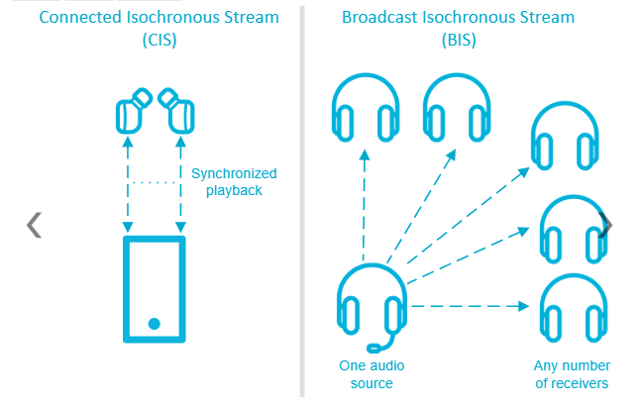

1 - Connected isochronous stream (CIS) mode
CIS is a bidirectional communication protocol that allows for sending separate connected audio streams from a source device to one or more receivers. The gateway can send the audio data using both the left and the right ISO channels at the same time, allowing for stereophonic sound reproduction with synchronized playback.

2 - Broadcast Isochronous Stream (BIS)
BIS is a unidirectional communication protocol that allows for broadcasting one or more audio streams from a source device to an unlimited number of receivers that are not connected to the source.

Firmware architecture

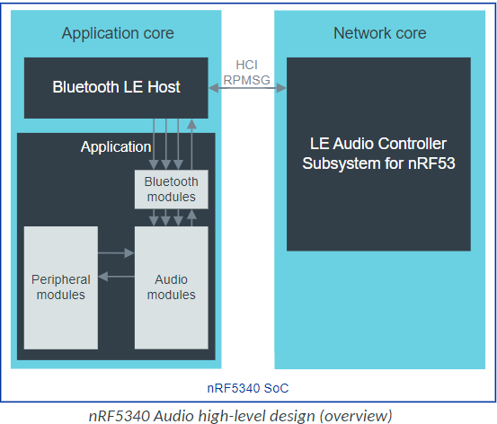
USB-based firmware for gateway
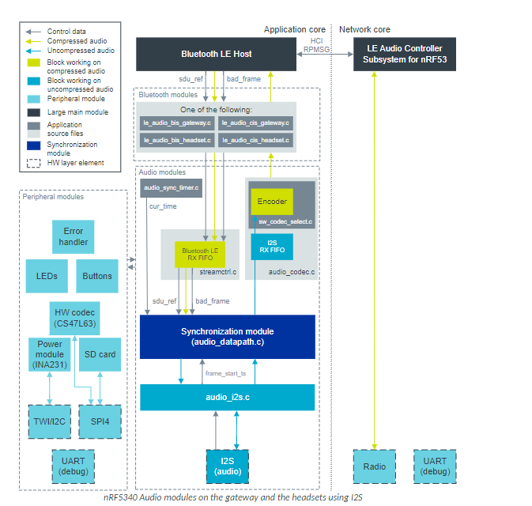

Requirements

Software codec requirements

The nRF5340 Audio application only supports the LC3 software codec, developed specifically for use with LE Audio.

nRF5340 Audio configuration files
Only one of the following .conf files is included when building:
- prj.conf is the default configuration file and it implements the debug application version.
- prj_release.conf is the optional configuration file and it implements the release application version. No debug features are enabled in the release application version. When building using the command line, you must explicitly specify if prj_release.conf is going to be included instead of prj.conf .

Switches , button and LED's configurations :

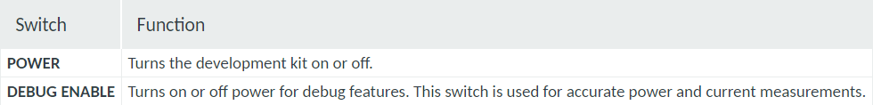

Button :
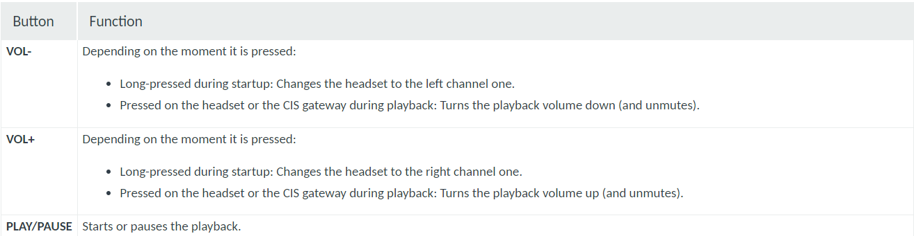

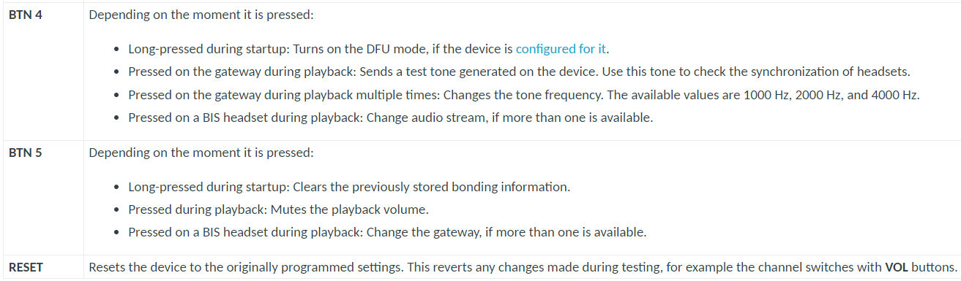

LED's
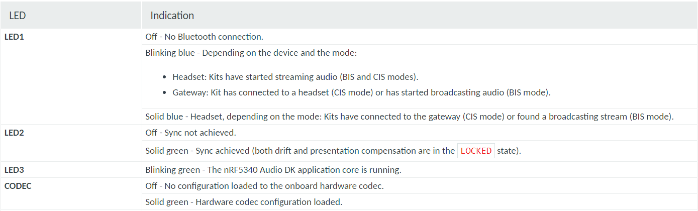

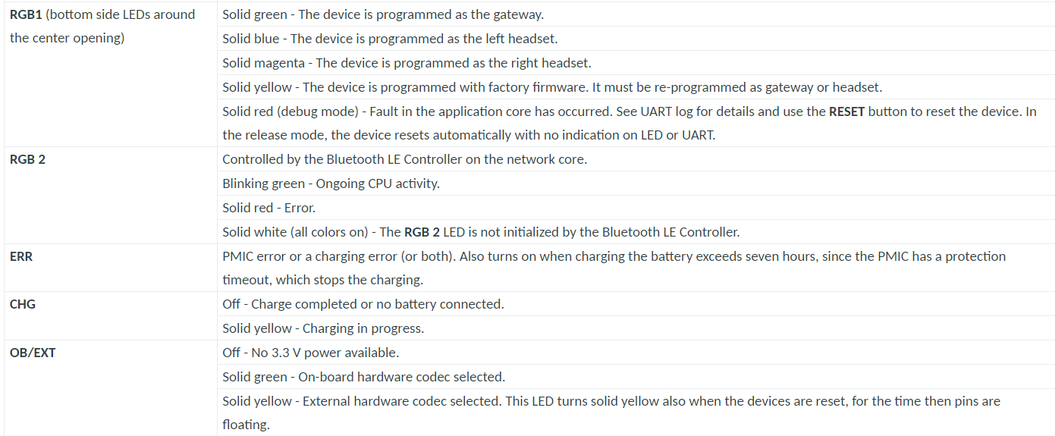

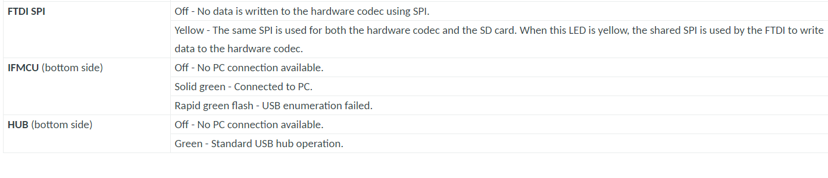

Configuration (prj.config)
Friday, October 18, 2024
2:45 PM

Configuration for broadcast source -- BIS gateway

CONFIG_SW_CODEC_LC3=y
CONFIG_BT_LOG_SNIFFER_INFO=y
CONFIG_TRANSPORT_BIS=y
CONFIG_AUDIO_DEV=2
CONFIG_BT_BAP_BROADCAST_SOURCE=y

Configuration for broadcast source -- CIS gateway

CONFIG_SW_CODEC_LC3=y
CONFIG_BT_LOG_SNIFFER_INFO=y
CONFIG_TRANSPORT_CIS=y
CONFIG_AUDIO_DEV=2
CONFIG_BT_BAP_UNICAST_CLIENT=y

Volume control
Wednesday, October 30, 2024
12:32 PM

VCP is the volume control profile

BAP
Monday, November 4, 2024
12:27 PM

Basic audio profile ::
The Basic Audio Profile (BAP) defines procedures for Audio Stream control by using the Generic Attribute Profile (GATT) and the Generic Access Profile (GAP) for devices that want to use Bluetooth Low Energy (LE) in audio-related scenarios

Profile dependencies for BAP:
1 - GATT
2 - GAP
3 - ASCS
4 - PACS
5 - BASS
6 - LL

Profile and protocol stack
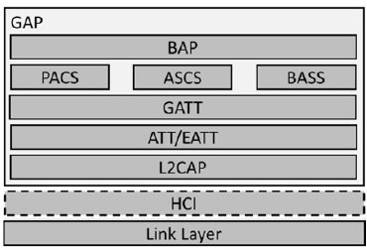

The roles that are supported by BAP
There are 6 roles in BAP
-->unicast roles
1 - Unicast server & Unicast client
-->broadcast roles
2 - Broadcast source & Broadcast sink
3 - Broadcast assistant & Scan delegator

Unicast server::
The Unicast Server transmits advertisements that the Unicast Client uses to discover the Unicast Server
and to establish connections to the Unicast Server.

Q&A
Tuesday, October 15, 2024
6:50 PM

  - Why we use include characteristics attribute in GATT?
  - How the framed & unframed data is saparated from multiplexer in lsoal?
  - What the maximum sdu length that can be received to isoal layer?
  - What is differnce between segmentation and fragmentation?
  - Why we use eatt instead on att ?
  - why we use adv_ext_ind and aux_adv_ind in le audio instead of adv_ind?
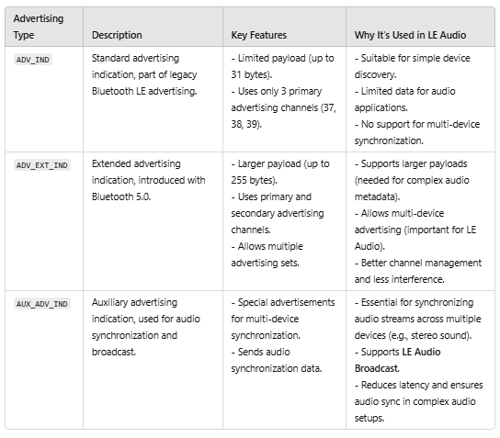

How the data is taken in the header ?

1 - What is differeence between segmentation and fragmentation >
segmentation is the process of breaking up a single L2CAP SDU into multiple L2CAP packets, while fragmentation is the process of splitting larger packets into multiple link layer packets
  - Segmentation
Splits a single L2CAP SDU into multiple L2CAP packets called SDU segments. This process ensures that large sets of application data are transferred efficiently.
  - Fragmentation
Splits larger packets into multiple link layer packets, which are then reassembled by the link layer of the peer device. This process allows L2CAP and higher-level protocols to use larger payload sizes.
  - Examples of textbooks

What differs the working of l2cap and isoal layer

Topics list
Monday, November 11, 2024
4:04 PM

-->
-->What is LE and why we use LE -->history
-->Introducing of LE AUDIO
-->Uses of LE Audio
àAdvertising
àTypes of advertising
àDifferent advertising PDU’s
àextended adv payload format

Monday, December 23, 2024
7:26 AM

Wednesday, November 13, 2024
12:00 PM

-->Into of me good morning !!
Just recap last session !! Answer for the question from last session
Today we are discussing about advertising ,
Brief about le audio y we are discuusing advertisement..
what is mainly advertising
Types of advertising
Leagcy
-->packets
Extended
-->channels
-->packets
what packcts can be the other AUX after aux_adv_ext ,
Event diagram , T_MAFS , T_IFS

LC3 CODEC
Tuesday, December 3, 2024
3:26 PM

Sampling ::
What is Sampling?
Sampling is the process of converting a continuous audio signal (such as a sound wave) into a discrete digital signal by taking periodic measurements of the amplitude of the sound at specific points in time. These measurements are called samples

Quantization is the process of converting a continuous range of values (such as the amplitude of an analog signal) into a finite set of discrete values. This is a crucial step in the process of converting an analog signal (like sound) into a digital format, after sampling.

Sampling Rate (also known as Sample Rate or Sampling Frequency) is the number of samples taken per second when sampling an audio signal. It is typically measured in samples per second (Hz), and it determines how accurately the digital representation captures the original analog signal.

